SIMATS ENGINEERING
ASSESSMENT TOOL 2
COURSE NAME: Design and Analysis of Algorithms COURSE CODE: CSA06

COURSE OUTCOME COVERED
CO2: Apply Brute Force technique to solve sorting, searching, Closest-Pair and Convex-Hull problems (BL1,BL2,BL3)
Assessment Tool Weightage: 20%

QUESTIONS: 1 Total Marks: 50
Annexure A
Scenario Based Assessment

Code of Conduct:
I P.SUDHARSHAN REDDY(192372204) (Name / Reg No) certify that this submission is my original work and that I have adhered to the guidelines specified for this assessment.
I understand that any violation of academic integrity rules will result in disciplinary action.
Signature of the student:
SUDHARSHAN REDDY
31-07-2026

Q60. Brute-Force Convex Hull for Drone Surveillance
A drone surveillance system detects the outer boundary of objects using brute-force convex hull computation.

1. Problem Statement
A drone surveillance system scans an area and captures a set of boundary points for each object it detects (for example, points sampled along the silhouette of a vehicle, building, or restricted zone from camera/LIDAR data). The system must compute the outer boundary — the convex hull — of each object's point set using the Brute Force technique, so that the smallest convex region enclosing all the points can be displayed, tracked, and logged in real time.

2. a) How the Convex Hull is Determined (Brute Force)
The Brute Force approach determines the convex hull by testing every possible pair of points as a candidate edge of the hull, and checking whether all remaining points lie strictly on one side of the line formed by that pair. If they do, the pair forms an edge of the convex hull; otherwise it is discarded.
- For every ordered pair of points (Pi, Pj) in the set of n detected points, form the line through Pi and Pj.
- For every other point Pk, compute the cross product (Pj − Pi) × (Pk − Pi) to determine which side of the line Pk lies on.
- If all other points lie on the same side (all cross products are ≥ 0, or all ≤ 0), the pair (Pi, Pj) is an edge of the convex hull.
- Collect all such qualifying edges; joining them in order traces the outer boundary of the object.
The figure below illustrates this for a small cluster of detected boundary points: every accepted edge (highlighted) has all remaining points lying on a single side of it, which is exactly the brute-force test being applied.
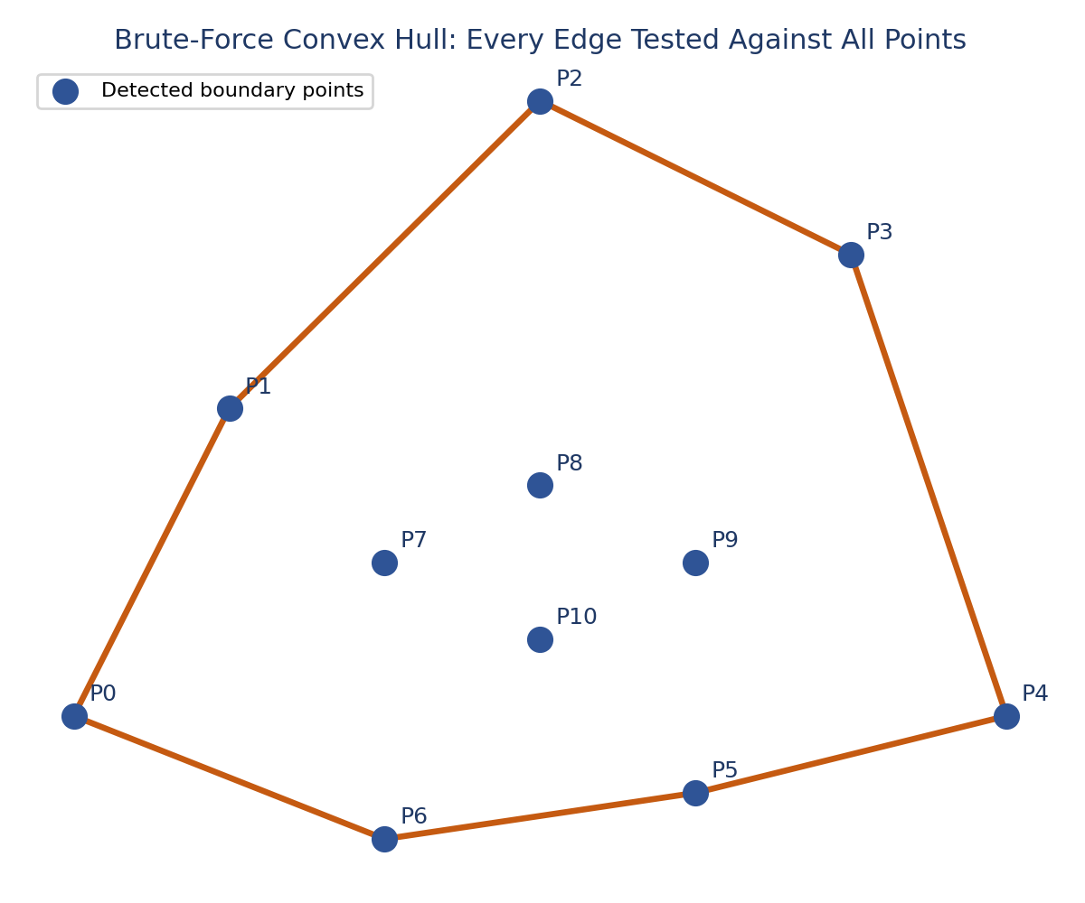

3. b) Time Complexity Analysis
For each of the n(n−1) ordered pairs of points, the algorithm inspects the remaining (n−2) points to check which side of the line they fall on. This gives:
T(n) = O(n) pairs-check × O(n) points × O(n) pairs ≈ O(n³)
More precisely, there are O(n²) candidate pairs, and each pair requires an O(n) scan of the remaining points, giving an overall worst-case time complexity of O(n³). The space complexity is O(n) to store the input points and the resulting hull edges.

Algorithm | Time Complexity | Suitability
Brute Force (edge test) | O(n³) | Small point sets; simple, easy to verify
Graham Scan | O(n log n) | Large point sets; needs sorting by angle
Jarvis March (Gift Wrapping) | O(n × h) | Efficient when hull points h is small
Divide and Conquer | O(n log n) | Large-scale, parallelisable

4. c) Scalability Challenges
- Cubic growth: as the number of boundary points per object (n) increases (denser LIDAR scans, higher-resolution cameras), computation time grows as O(n³), quickly becoming impractical for real-time drone feeds.
- Multiple simultaneous objects: a surveillance drone may track many objects at once; running brute-force hull computation independently for each object multiplies the total cost linearly with the number of objects.
- Continuous/streaming data: drone sensors continuously emit new points as the object moves or the drone repositions, forcing repeated full recomputation rather than incremental updates.
- Real-time latency constraints: surveillance and obstacle-avoidance decisions require sub-second responses; O(n³) brute-force computation can violate these latency budgets as point counts rise.
- Onboard resource limits: drones have constrained CPU, memory, and battery power, making cubic-time computation costly to run directly on the drone versus offloading to a ground server.
- Noise and outliers: sensor noise can introduce spurious far-away points that distort the hull; brute force has no built-in filtering, so pre-processing becomes essential as data volume grows.
These challenges motivate migrating from brute-force O(n³) hull computation to faster O(n log n) algorithms (Graham Scan, Divide-and-Conquer) once point counts or the number of tracked objects grow beyond small, per-object clusters.
5. Analyze the Given Scenario
The scenario describes a drone-based surveillance system that must identify the outer boundary of objects it observes during a flight mission. Each object detected by the drone's camera or LIDAR sensor is represented as a cluster of 2D/3D points; the brute-force convex hull algorithm is applied to this cluster to compute the tightest enclosing boundary. This boundary is used to represent object shape/extent for tasks such as intrusion detection, no-fly-zone boundary marking, vehicle/object tracking, and area-coverage mapping.
Because brute force is computationally expensive at O(n³), the scenario naturally raises the need for a supporting software system: one that captures drone data, computes hulls efficiently for realistic (typically small, per-object) point counts, stores results for later review, and presents them to a human operator through a live dashboard — which is the system analyzed and designed in the remaining sections.

6. Identify User Requirements
User | Functional Need | Non-Functional Need
Drone Operator | View live video/map feed with convex hull boundaries overlaid on detected objects | Low latency (near real-time updates)
Surveillance Analyst | Browse historical missions, review logged object boundaries and hull point counts | Accurate, tamper-evident logs
Security Supervisor | Receive alerts when a new object appears or a hull boundary changes significantly | Reliable alerting, minimal false positives
System Administrator | Manage drone registrations, missions, and user accounts | Role-based access control, scalability
In summary, the system must: capture streaming point data from a drone, compute convex hulls per detected object, persist mission/object/hull data, present results visually in near real time, and support review and alerting for human operators.

7. Suggest Suitable Technologies
Layer | Suggested Technology | Reason
Hull Computation Engine | Python (NumPy) or C++ | Fast numerical operations; easy to prototype brute-force and later swap in O(n log n) algorithms
Backend / API | Node.js (Express) or Python (Flask/FastAPI) | Lightweight REST endpoints plus WebSocket support for real-time push updates
Real-Time Communication | WebSocket / MQTT | Low-latency, bidirectional streaming needed for live drone telemetry and hull updates
Database | PostgreSQL (with PostGIS) or MongoDB | Structured relational data (missions, drones, logs) with optional geospatial querying for coordinates
Frontend Dashboard | React.js + Mapbox/Leaflet.js | Component-based UI for live map rendering, hull overlays, and interactive controls
Hosting / Deployment | Cloud VM or container (AWS/Azure, Docker) | Scalable compute for multiple concurrent drone missions and dashboard users
This stack keeps the computationally heavy hull algorithm decoupled from the presentation layer, so the brute-force engine used here for CO2 (or a faster algorithm later) can be swapped without redesigning the rest of the system.

8. Design the Webpage / Database (Conceptual Design Only — Not Implemented)
Note: the designs below are conceptual mock-ups intended to illustrate the intended layout and data model. No working webpage or live database has been built for this assessment; they are presented purely as a design plan.

8.1 Webpage (Dashboard) Wireframe
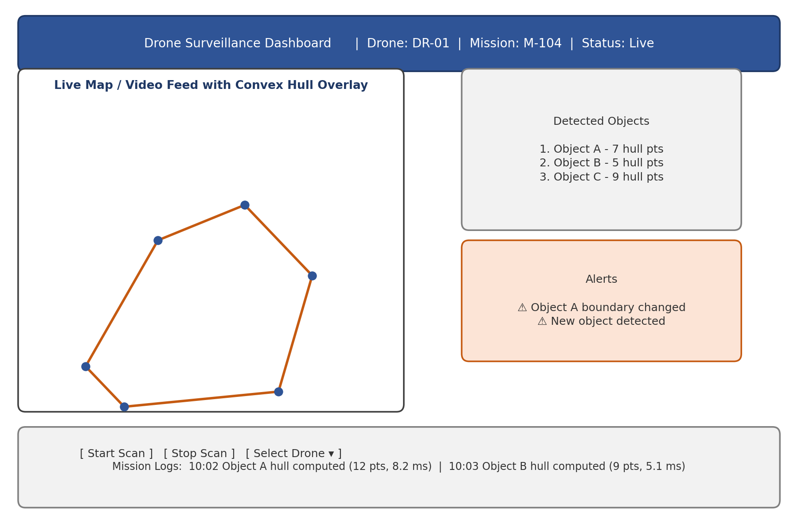
The imagined dashboard has four regions: (1) a top status bar showing the active drone and mission, (2) a central live map/video panel with the computed convex hull drawn over each detected object, (3) a right-hand panel listing all currently detected objects with their hull point counts, and an alerts panel for boundary-change notifications, and (4) a bottom log strip showing a running history of hull computations with timestamps.

8.2 Database Design (Entity-Relationship Diagram)
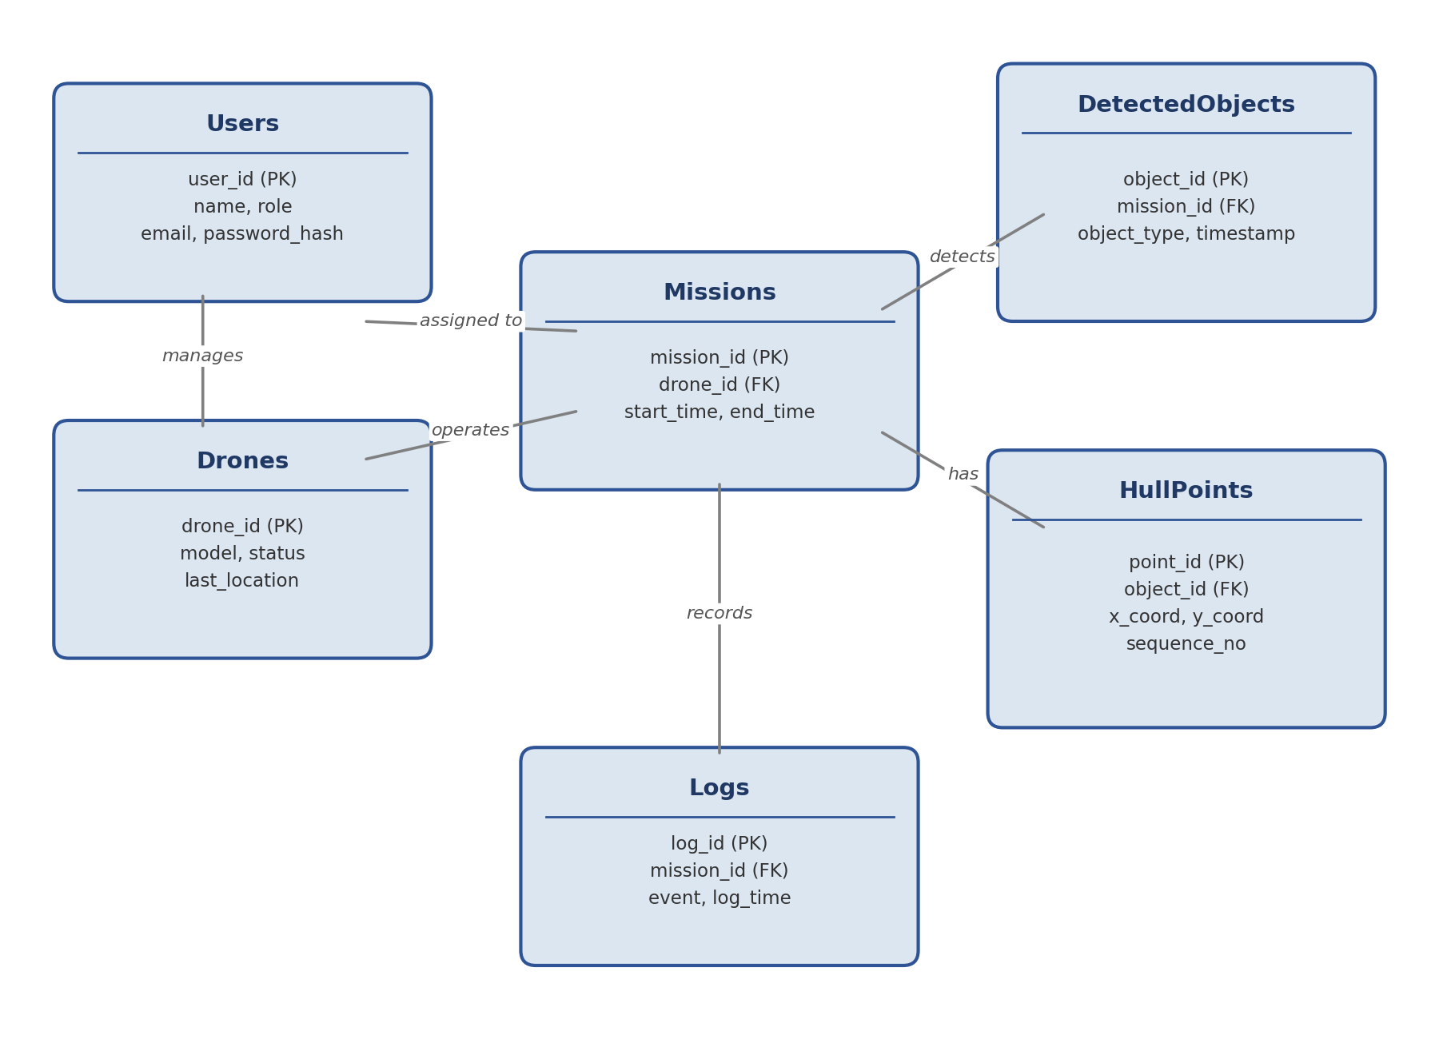
The conceptual schema has six entities: Users (dashboard accounts), Drones (registered devices), Missions (a flight session tied to a drone), DetectedObjects (one row per object found during a mission), HullPoints (the ordered boundary coordinates for each object's convex hull), and Logs (a timestamped event trail per mission). This normalized structure keeps raw hull coordinates separate from object metadata, allowing efficient querying of “all hull points for object X” without scanning unrelated data.

9. Explain Implementation Steps
- Data capture: the drone's onboard camera/LIDAR streams raw sensor frames; an onboard or edge module clusters points belonging to the same physical object.
- Preprocessing: each object's point cluster is denoised (outlier removal) before hull computation to avoid distortion from sensor noise.
- Hull computation: the cleaned point set (typically small, tens of points per object) is passed to the Brute-Force Convex Hull Engine, which tests all point pairs and returns the ordered hull vertices.
- Transmission: the drone/edge device sends the object metadata and hull vertices to the Backend API over a wireless link, using MQTT/WebSocket for low-latency delivery.
- Persistence: the Backend API stores the mission, object, and hull-point records in the database for later review and auditing.
- Live update: the Backend pushes the new hull data to all connected dashboard clients via WebSocket as soon as it is computed.
- Visualization: the React dashboard renders the updated hull polygon on the map/video overlay and updates the object list and logs in real time.
- Alerting: if a hull's shape or area changes beyond a configured threshold between updates, the system raises an alert in the dashboard's alerts panel.

10. Justify Design Decisions
- Brute Force for correctness at small scale: per-object point clusters after clustering/denoising are typically small (tens of points), so the O(n³) cost remains manageable per object and serves as a simple, easily verifiable baseline before optimizing.
- Decoupled hull engine: keeping the convex-hull computation as an independent module means it can later be replaced with Graham Scan or Divide-and-Conquer (O(n log n)) for larger point sets without redesigning the API, database, or dashboard.
- WebSocket/MQTT for live updates: polling the backend would add latency and unnecessary network load; a push-based protocol matches the real-time nature of surveillance data.
- Relational/geospatial database: mission, drone, and object relationships are naturally tabular (one mission has many objects, one object has many hull points), which relational modelling represents cleanly, while optional geospatial extensions (e.g., PostGIS) support future map-based queries.
- Separate HullPoints table: storing hull vertices as their own rows (rather than a single serialized blob) allows efficient querying, indexing, and incremental updates as an object's boundary changes over time.
- React-based dashboard: a component-based frontend framework makes it straightforward to independently update the map overlay, object list, and alerts panel as new WebSocket messages arrives.

11. Performance Evaluation
Since no system was implemented, performance is evaluated conceptually, describing the metrics that would be measured and the expected trend based on the O(n³) brute-force complexity derived in Part (b):
Metric | How It Would Be Measured | Expected Behaviour
Hull computation time | Wall-clock time for the brute-force engine per object, for n = 10, 20, 40, 80 points | Grows roughly cubically with n, consistent with O(n³)
End-to-end latency | Time from sensor capture to dashboard render, across the full pipeline | Dominated by hull computation once n exceeds a few dozen points
Throughput | Number of objects processed per second with multiple simultaneous detections | Decreases as the number of concurrent objects/points increases
Accuracy | Computed hull compared against a known/reference hull for the same test points | Exact match expected, since brute force is theoretically correct
Resource usage | CPU and memory usage of the hull engine under increasing load | CPU usage rises sharply with n; memory stays roughly O(n)
Based on the complexity analysis in Part (b), the brute-force engine is expected to remain responsive only while per-object point counts stay small (tens of points); beyond that, the pipeline's end-to-end latency would be increasingly dominated by hull computation, motivating the swap to an O(n log n) algorithm as a future performance optimization.

12. Conclusion
This assessment analysed a drone surveillance scenario where the outer boundary of detected objects is computed using the Brute Force convex hull technique. The method works by testing every pair of points as a candidate hull edge and verifying that all remaining points lie on one side of it, giving a correct but computationally expensive O(n³) algorithm. While this complexity is acceptable for the small, per-object point clusters typical of a clustered drone sensor pipeline, it poses clear scalability challenges as point density, object count, and real-time constraints increase. A supporting software system was conceptually designed around this algorithm — comprising a preprocessing and hull-computation pipeline, a REST/WebSocket backend, a relational database schema separating missions, objects, and hull points, and a live dashboard for operators — with each design decision justified by the need for correctness at small scale, real-time responsiveness, and a clear upgrade path to faster O(n log n) hull algorithms as the system scales.

